**Event HUB**

1. Create an event hub namespace. In that create an event hub. Now while creating the event hub, it will ask you to create a storage account for storing the events (its optional). Make sure that storage account has the anonymous access enabled and the container is not private. After that create a consumer group in the event hub. 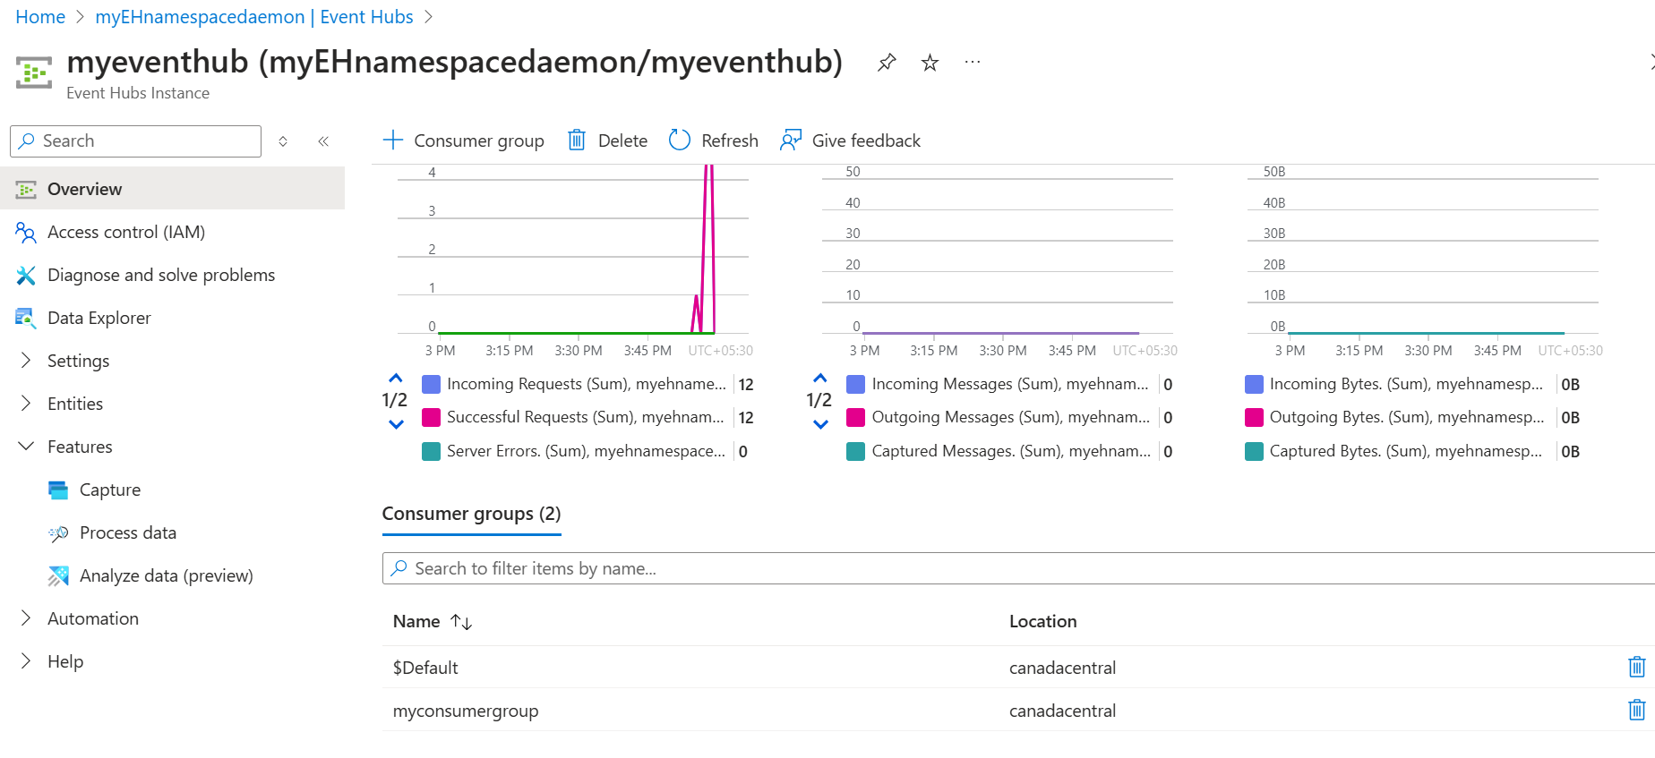
2. In PyCharm, from view 🡪 Tools 🡪 Python Packages install azure-event-hub (and all related packages they will list under the same) Use below program to send events in event hub. 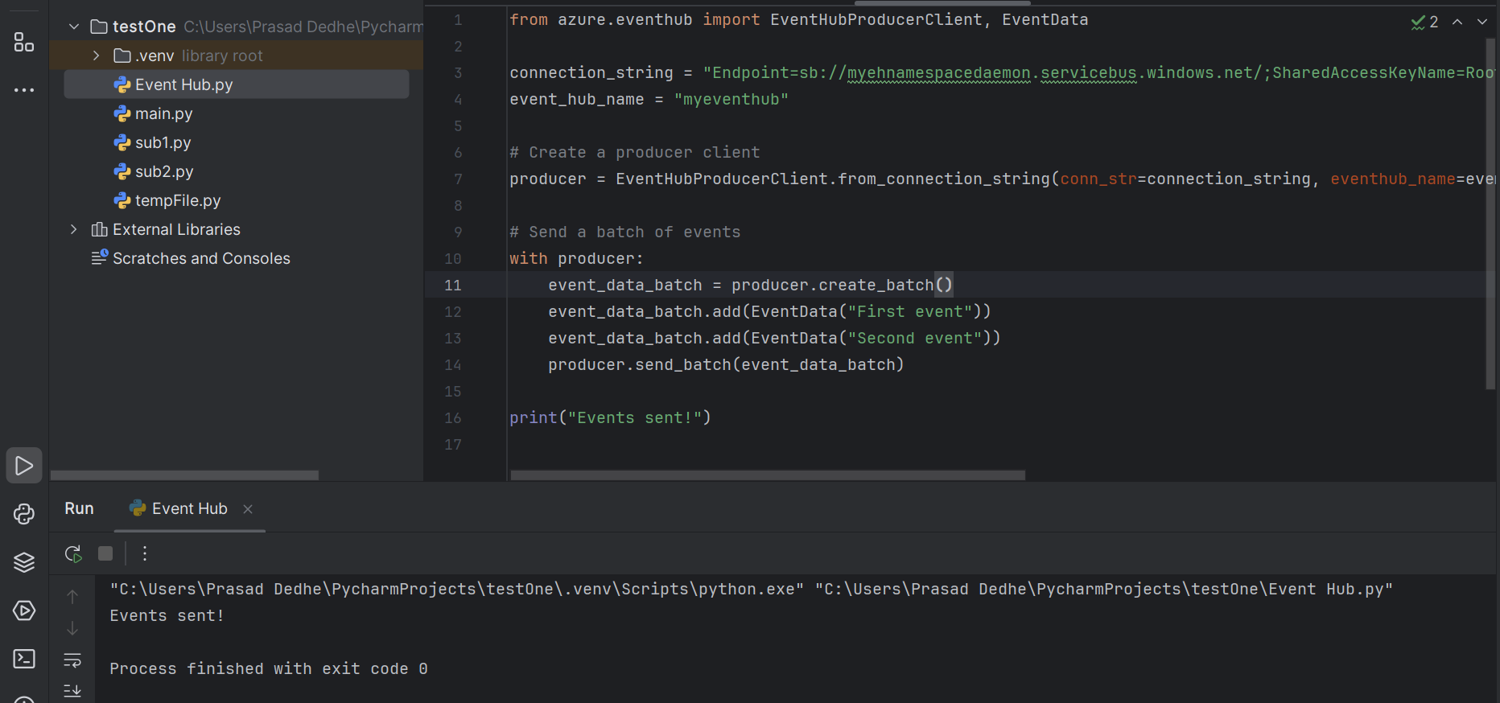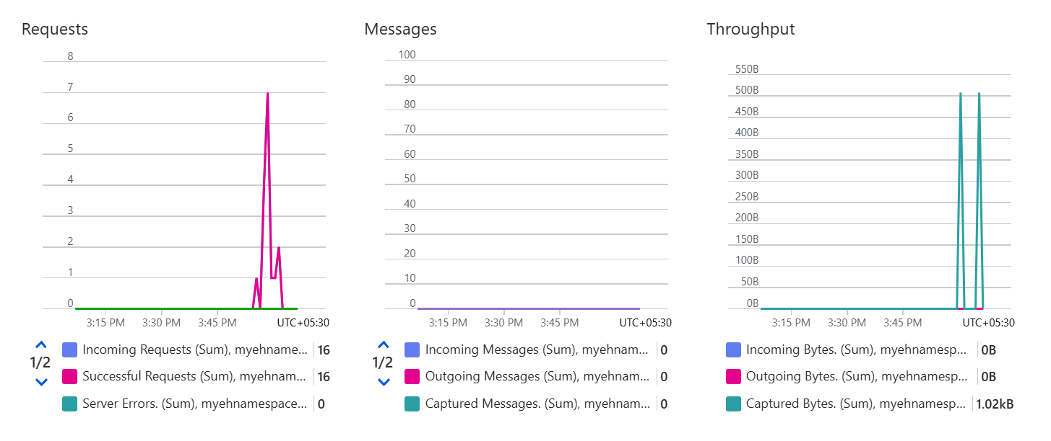
3. The events will be stored in the storage account in avro format. You can use online avro to json coverter tool. 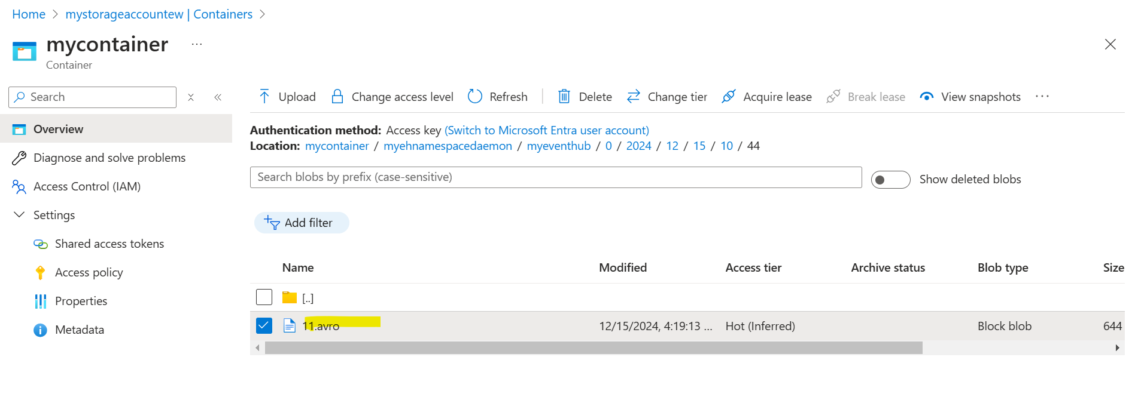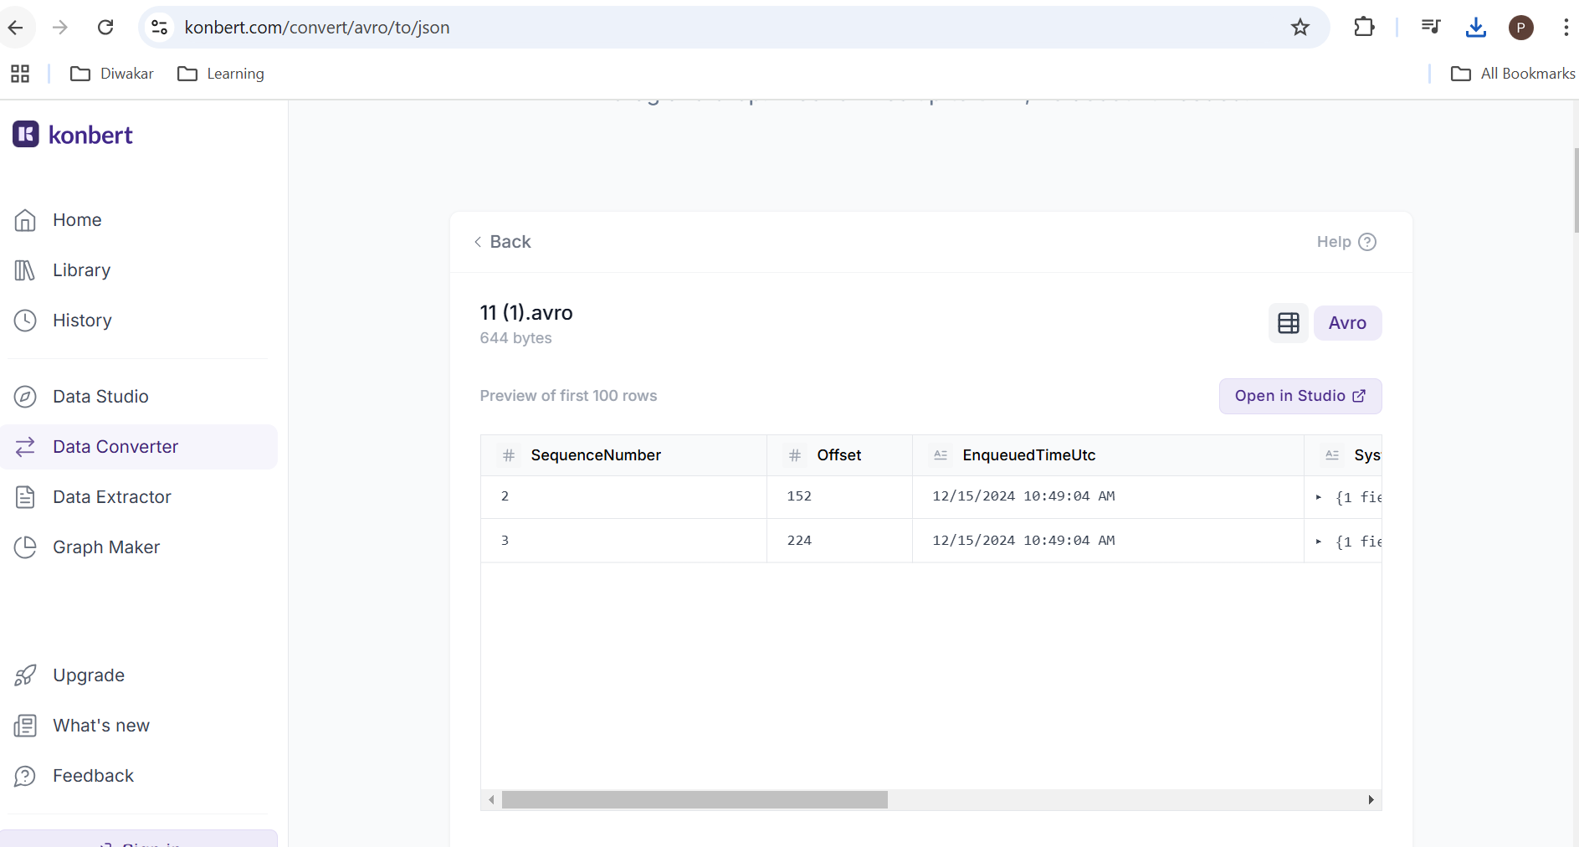
4. Use below program to receive the events.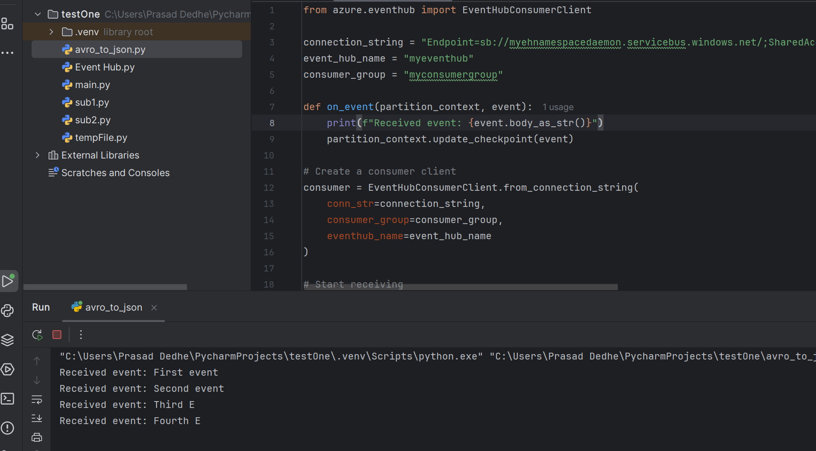 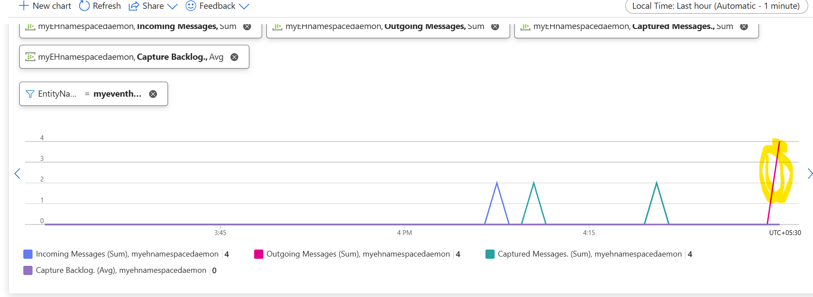
5. Use case – I have created an event suscription in storage account (there is a separate SOP for how to do that), then I have added the storage account as the endpoint, so whenever a blob would be created or deleted then, the event would be generated. The file was uploaded and the event was received. 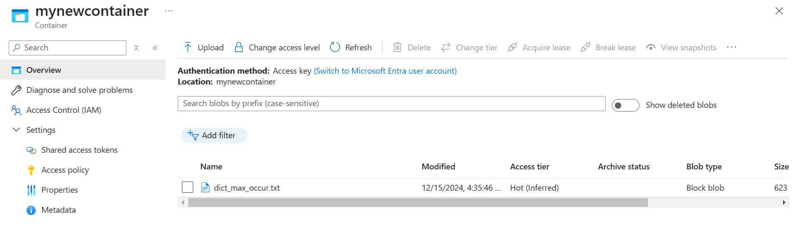
6. Even the information regarding the event has been stored in the storage account. Remember that there is no data of the event, just metadata stored in the storage account. 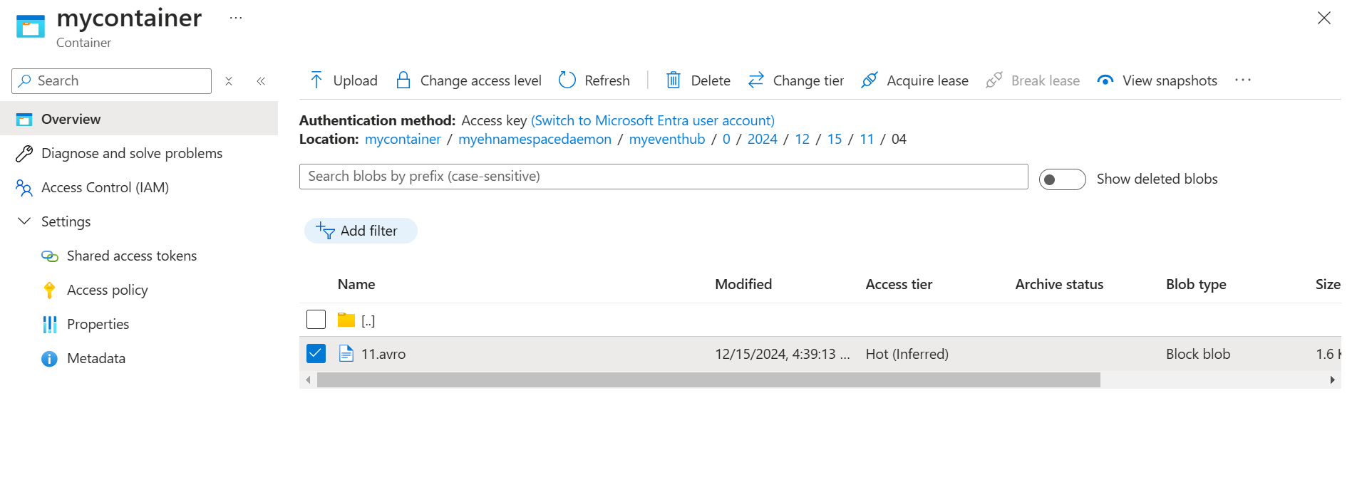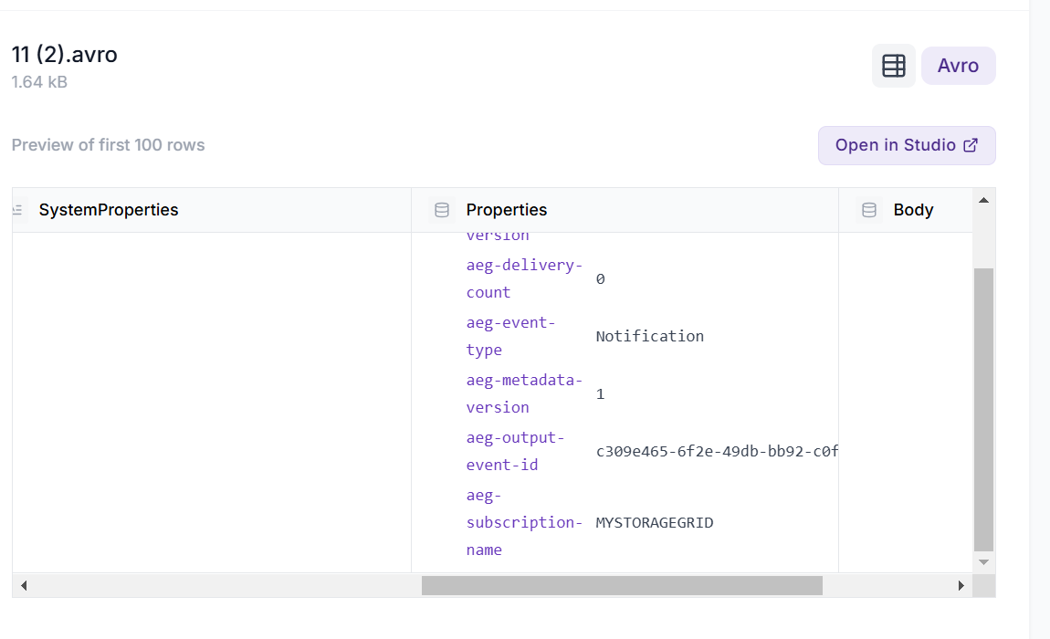
7. In the data explorer, you can send & receive the events directly from the portal. 